Zoey Hankins #011313675
July 18, 2024
User Interface Design – D279
UTM1 — UTM1 TASK 1: PROJECT PROPOSAL WITH STRATEGIES

- Determine the information architecture for the new Paradigm Pet Professionals website based on the attached “Paradigm Pet Professional UI Design Specifications” by doing the following:
A1. Explain the necessary website functionality and micro interactions needed to meet audience and stakeholder needs.
There are no forms on the website that a user might send to a stakeholder. As a result, the audience cannot ask the stakeholders about the goods or services they provide. There isn't a calendar accessible. The user cannot make an appointment. As a result, the user cannot communicate with the company about pet-related issues. When navigating, the navigation bar's functionality needs to be corrected. The term "cat" is italicized on the dog page. The navigation menu bar on the mobile website is tiny, and it is challenging for users to switch between web pages. The ability for the audience to get in touch with the stakeholders for their supplied goods or services is one of the essential micro interactions and website functionalities required to suit the needs of the audience and stakeholders. A phone number, business address, or contact form on a Contact Us webpage could be used for this. Fixing the navigation menu is necessary. Accessing the primary site menus after fixing the navigation menu will be more straightforward. Content linked to the company's website should be appropriately cited or more pertinent to the covered subject.
A2. Describe the type of content that will be used for one new page based on one of the new user personas, including how the elements of the content align directly to the chosen user persona.
For the user to maintain their bird's well-being, content regarding their birds' needs would be necessary to fulfill the user persona for birds. The material will address bird unhappiness and despair and how to tell if a bird is sick. If the bird does get sick, the article will advise where to take them.
A3. Identify existing content from the website that will be removed or redeveloped and explain how that content fails to meet the proposed audience and stakeholder needs.
It will be necessary to delete the images of the snakes from the homepage and replace them with pictures of birds because they clash with the website's overall theme. Content about dog toys and exercise will need to be revised on the dog page to suit the user persona of dog owners better. The current content falls short of their expectations because it lacks the content the audience is searching for. The persona for the cat page is expecting information about feeding requirements and suggestions for the healthiest meals for cats at every stage of development. The page satisfies the persona's needs because this content is present. The dog page persona anticipates seeing recommendations for the best pet toys that promote activity and information that meets the exercise needs that their dogs require throughout their lives. The user persona for the dog page is not satisfied because the current content does not meet these demands. The stakeholder anticipates that the material will encourage audience members to schedule consultations and offer essential pet care advice. The audience is not encouraged to schedule consultations at home or on any page. It will be necessary to redesign the home page to make room for consultations and motivate viewers to schedule them. Because it doesn't offer the audience's expected basic pet care information, the current material on the dog page does not satisfy the needs of the stakeholders either.
A4. Create a visual sitemap to determine the structure and the hierarchy of the site content, including the following:
- a home page
- a page for each existing pet page
- a new page for the new user persona identified in part A2
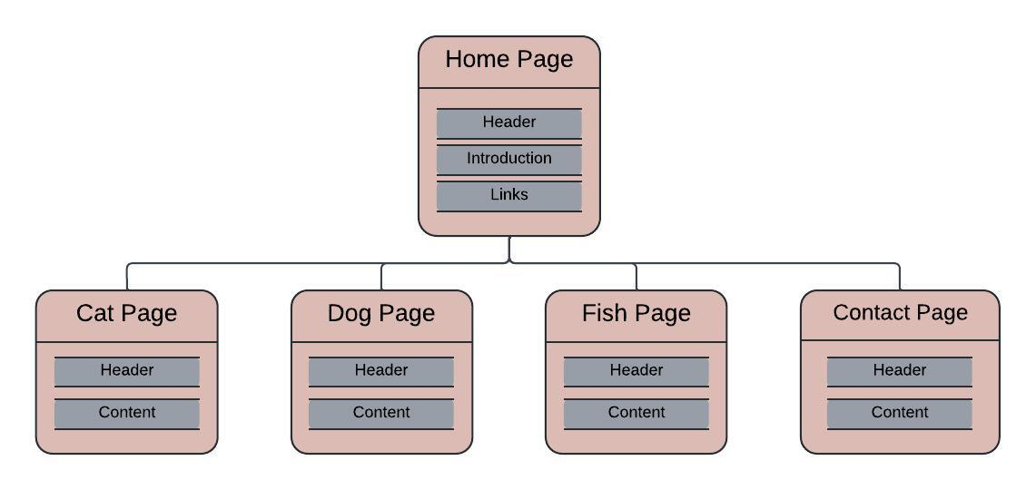
A5. Explain how your information architecture meets audience and stakeholder needs.
The content stakeholders and users expect to see will be included in the information architecture on the home page. It will consist of links to the relevant sections, a description of the company's activities, and images of the various animals on the website. Every page will include a navigation bar at the top that lets users navigate to the pages they want. The only information on the sites will be pertinent to their animal. A form on the contact page will enable users to schedule one-on-one appointments with the site owner. Because the current content on the dog page will be updated to address the demands of activities throughout the dog's life and to make recommendations for the best dog toys for physical exercise, the audience's needs will be satisfied. Because the material on every page will meet the audience's expectations for primary pet care, the needs of the stakeholders will be met. The current structure will add two more pages, one of which will collect audience information required to schedule consultations. The audience will be encouraged to schedule one-on-one sessions on this contact page. The information on the second page, which will be added, is intended for bird owners and will address the relationship requirements of their birds to maintain their appropriate well-being. This additional content will meet the requirements of the various personas. The information on the website will be readable and simple to comprehend, and it will be straightforward to browse. This information architecture will effectively address each stakeholder's unique needs.
A6. Explain the primary and secondary navigational elements required to support the information architecture.
Labels that point to webpage items are the primary type of navigation element. These main navigation components support the information architecture. The audience can locate the pertinent content on the webpage with the help of the main navigation elements. For instance, the labels "zero to four weeks," "four weeks to one year," "one year to seven years," and "seven years and more" are examples of the main navigation components for the "cats" webpage. Thanks to these significant navigation labels, the user can quickly locate the information they need without having to sift through a ton of content.
Users can browse specific web pages inside the website using the secondary navigational elements. For instance, the user can access the five other primary pages—"cats," "dogs," "birds," and "contact us"—while still on the homepage. Users can focus on essential subjects pertinent to them with the help of the secondary navigation style, which enhances the information architecture. The webpage's content is now relevant to the audience's search for information.
a. Explain how these primary and secondary navigational elements each align with audience and stakeholder needs.
The navigational elements align with the audience and stakeholder needs because they give both the audience and the stakeholder a sense of clarity and direction. The stakeholder must provide information regarding the business aims and objectives of the pet firm. The stakeholder supplies this data under secondary navigation components to accomplish this. The stakeholder uses the main navigation elements, which offer more detail about the pet company's business goals, information, and objectives, to provide further details. At this point, the information will match the user's requirements, desires, and expectations. The user can locate the desired information by navigating through the primary and secondary navigation elements. It will make the audience less perplexed. In essence, when presented correctly, an architecture that is appropriately designed aligns the needs of the organization and its users simultaneously.

B. Determine page layout by creating a mid-fidelity wireframe for the home page that is sized for a desktop website that includes each of the following:
- site header, including the branding elements
- site footer
- primary and secondary navigational elements
- placeholder text and placeholder images
- specific components needed to support the information architecture (e.g., buttons, links, form fields, search bar)
